Climate Change and Adaptations:
Climate change is one of the most important pressing global issues. It is perhaps the greatest challenge humanity has ever faced. It has affected every corner of the planet – from the poles to the tropics, and from the mountains to the oceans. People and nature worldwide felt the effects: water supplies are shrinking, extreme weather events increasing in frequency and intensity, forests burning, and coral reefs dying.
The Poet says- ‘The woods are lovely dark and deep’. Yes, we, the global people have the responsibility to keep the world beautiful. We can still escape the worst impacts of climate change and build a safer world for all.
But we have to do more, and act fast. It’s very important to step up efforts to switch from using fossil fuels – the biggest cause of climate change – to clean, renewable energy. We need to help people and adapt to the inevitable changes ahead in nature.
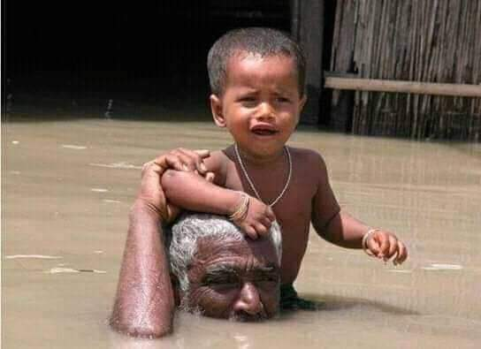

Flood affected the lives of the people and rendered them homeless
Bangladesh is one of the most vulnerable countries to climate change. Bangladesh ranked as the seventh country most affected in the world due to ‘extreme weather events’ over the last 20 years in 1998-2017, said a new global report.
Specialties of six seasons were lost and the natural routine events changed. Bangladesh has four and not six seasons .The four seasons include pre-monsoon, monsoon, post-monsoon and winter.
Cold waves and hot waves have now been regular features. Death toll by lightning strikes is on the increase. The salinity from sea is creeping into the mainland. Salinity affects land and water in the coastal areas. The country had to bear the harsh blow of cyclone Sidr in 2007, haor [Wetland] flooding in 2017 and frequent inland tornadoes. Salinity mainly affects land and water in the coastal areas.

According to a UNICEF report released in April, 2019 about 19 million Bangladeshi Children are at risk from climate change disasters such as flood and cyclone.
Cyclone Fani and Bulbul hit Bangladesh this year damaging crops worth millions of dollars. Around 677,000 hectares of crop lands were marooned in last July flood affecting about six million people in the country.

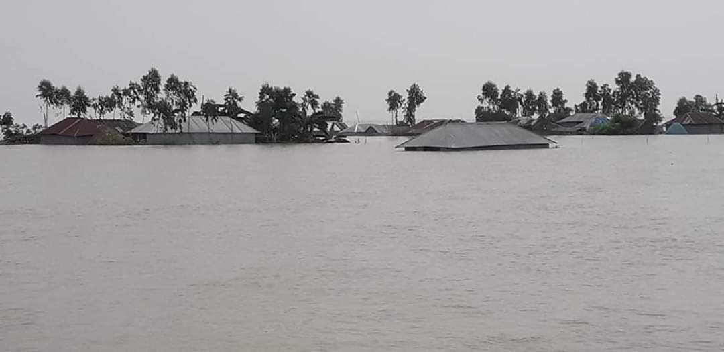

Flood marooned vast track of lands and villages
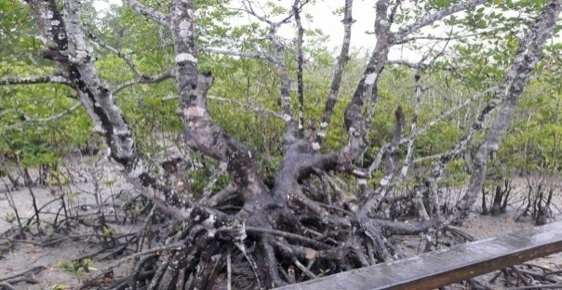
Constant rise in sea levels and climate change brought a catastrophic situation to the world’s biggest mangrove forest Sunderbans- causing threats to wildlife stronghold.

Cyclone hits the mangrove forest Sundarban
Bangladesh Government has taken lot of measures to cope with the adversities and is working relentlessly.
The measures include- plinth rising to secure the low lying land during flood, setting biogas plants to keep better climatic condition, massive tree plantation help reduce river erosion and keep the temperature in bearable condition, installing solar panel to reduce carbon, introducing developed crop varieties to ensure food security and quick information delivery during natural calamities through mass media to reduce the losses.
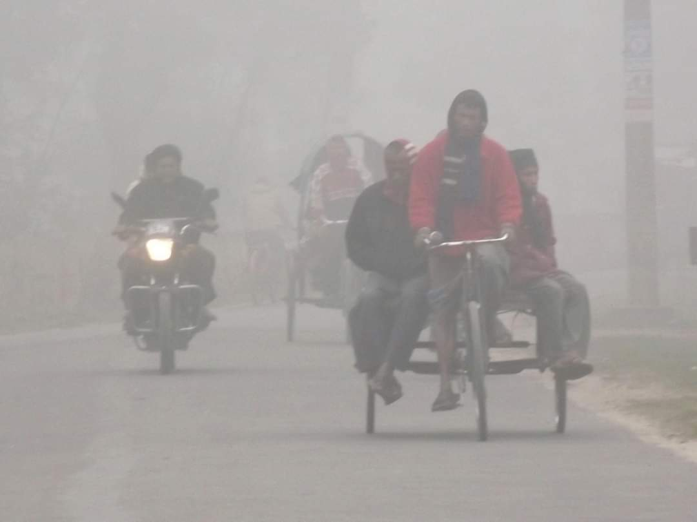

Cold wave paralyzed the regular lives of the people

Bangladesh Climate Change Trust Fund was created to implement climate-related projects with its own fund. Bangladesh has the right to receive funds from the Global Climate Fund of the United Nations for adaptation measures and for the protection of infrastructure as a vulnerable country. But the availability of such funds is uncertain and irregular. .
Agriculture in Bangladesh became most vulnerable facing heavy losses for the affects of climate change, according to the agriculturists and agriculture researchers. Frequent floods and storms badly affected the agriculture.
A statistics of Economic department of Bangladesh Rice Research Institute, Gajipur showed that about 90 thousands hectares of farm lands were decreasing in the country every year on an average 247 hectares everyday due to mainly overpopulation and effects of climate change. The rate of average lifetime of the people, however, increased in the country, which made challenge the food security in the country.
Crop Diversification and high yielding crop variety program shielded the climate change effects in agriculture meeting the food shortage in the country. Agriculture scientists invented high yielding catastrophic tolerant rice variety to minimize the damage and ensure the food security.
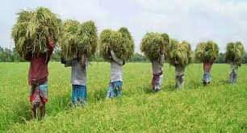

Farmers are harvesting high yielding variety of crop
The country installed about five million solar home systems in off-grid areas over the last few years.
Massive tree plantation programs were taken across the country. Students and the community people became aware of the program and they are taking part to make the environment green. They were given disaster Management training to adapt and to help the victims.
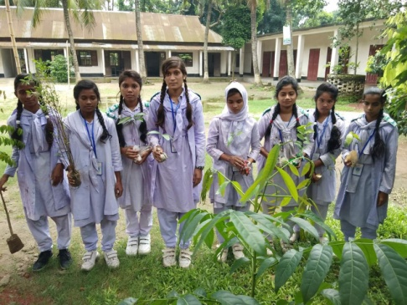

Students are taking part in plantation program.
Teachers in schools are teaching the students UN’s Sustainable Development Goals [SDG]. They are imparting the children the knowledge how we can all try to live more sustainably.
Former UN secretary general Ban Ki-moon said, ‘Bangladesh is the best teacher in climate change adaptation’ in a conference on ‘Climate change’ in Dhaka recently and lauded the innovative adaptation practices of Bangladesh.
The developed countries are the biggest polluters that caused global warming who must take responsibility to compensate the developing nations for their losses. The countries are yet to disburse most of the funds they have committed to combat climate change.
United Nation wants to transform the world –and make sure no one is left behind by 2030. So, let’s be united to combat climate change in order to reach the Global goals.

