Flood Control in Bangladesh
Md. Fazle Sobhan
Lecturer in Geography
Sir J C Bose Institution and College
Rarikhal, Sreenagar, Munshigonj.

Introduction: Bangladesh is a riverine country located in South Asia bordered by West Bengal ( India) on the west, Assan and Meghalaya( India) on the north, and Assam, Tripura and Mizoram on the north-east and Mayanmar on the south-east and the Bay of Bengal on the south ( Rashid,1991). About 700 rivers with their tributaries and distributaries are flowing over the land of Bangladesh. Due to the location of Himalayan Mountain on the north part of Bangladesh, our country is gradually slopping down from northern part to southern part. Most of the rivers after originating from the Himalayan Mountains fall on the Bay of Bengal. When excessive rainfall occurs, river water falls from upstream to downstream. Due to heavy siltation on the riverbed, most of the rivers’ water of our country overflow and sometimes causes flood. The 1987 and 1988 floods have caused great sufferings to the people of our country as well as caused loss of lives and heavy property losses. The 1998 flood was also the nightmare for the people of our country. Besides, medium or big floods are also occurring in the country almost every year. This year’s flood also has caused loss of lives and property in many districts of Bangladesh. The 2020 flood have inundated almost a quarter of Bangladesh and lost many valuable lives followed by devastating cyclone. The cyclone also pummeled the country’s southwest region. Along the sea, the rising sea had swallowed the entire villages for which it is believed that climate change is responsible. An estimated 24 to 34 of the country’s landmass had been submerged, nearly a million homes were inundated and 4.7 million people were affected in 2020 flood in Bangladesh while 54 were died, most of them children.

Flood Types: In Bangladesh four types of flood are noticed which include flash flood, flood due to local rainfall, river flood and coastal flooding. Severe floods occur due to some factors such as local intense rainfall, huge trans-boundary inflows and cyclone induced surges. Severe floods occurred in 1954, 1955, 1970, 1974, 1984, 1987, 1988, 2004 and 2007. Besides severe coastal flooding occurred in the year 1822, 1876, 1897, 1942, 1950 , 1970, 1974, 1988, 1991, 1994, 1995, 2007, and 2020.
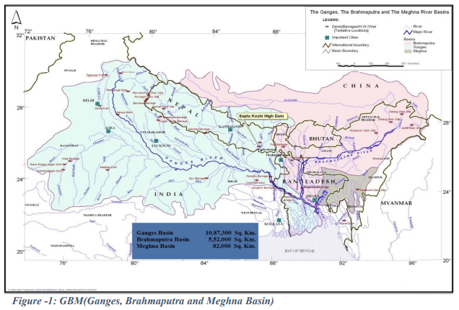
Source: Adopted from (Mirza et. al 2017)

How to control flood: In order to control flood in Bangladesh some measures are to be taken. Following measures are suitable for tackling flood.
1. Introduction of better flood warning systems

2. Modify homes and businesses to help them withstand floods.
3. Construct homes above flood level
4. Construct embankments on the bank of the rivers
5. Protect wetlands and tree plantation
6. Restore rivers to their natural courses
7. Introduction of water storage areas
8. Put up more flood barriers
9. Tackle climate change
10. Adaptation of flood

Conclusion: Flood control in Bangladesh is an urgent issue because flood visit the country almost all the year. Our infrastructure developments have been going on in full swing under the leadership of our honorable Prime Minister Sheikh Hasina. If we cannot control the flood, although it is a mammoth task all our effort to reach the country in the developed one by 2041 may face an obstacle. The 2020 flood have warned us that our precaution measures for tackling floods have to be strengthened. We believe that we are able to control the flood by our all-out efforts in future.

