To the people of the world
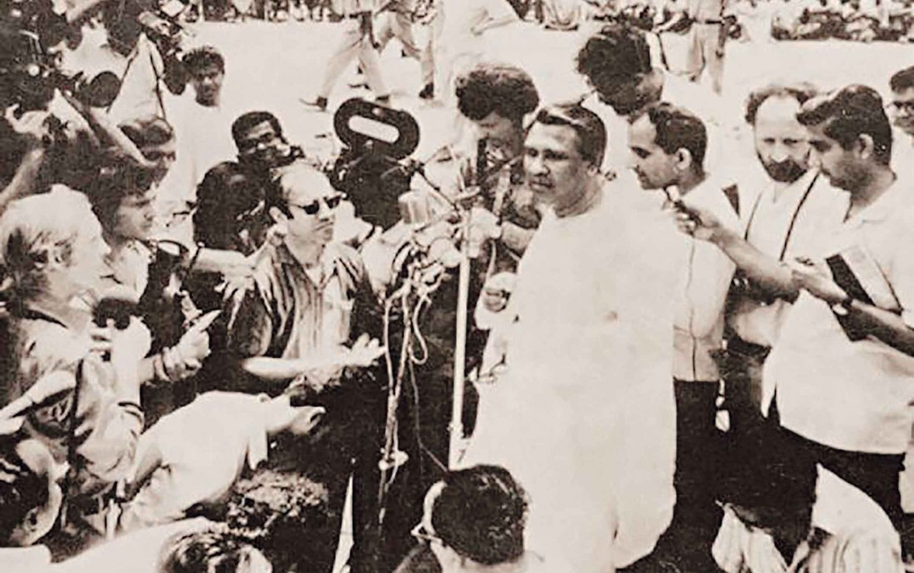
Tajuddin Ahmad, the Prime Minister of Mujibnagar Government, speaking to the journalists on April 17, 1971.
This statement was issued by the Prime Minister of Bangladesh, Tajuddin Ahmad, on April 17, 1971
Bangladesh is at war. It has been given no choice but to secure its right of self-determination through a national liberation struggle against the colonial oppression of West Pakistan..
In the face of positive attempts by the Government of Pakistan to distort the facts in a desperate attempt to cover up their war of genocide in Bangladesh, the world must be told the circumstances under which the peace-loving people of Bangladesh were driven to substitute armed struggle for parliamentary politics to realize the just aspirations of the people of Bangladesh.
The Six-Point Programme for autonomy for Bangladesh within Pakistan had been put forward in all sincerity by the Awami League as the last possible solution to preserve the integrity of Pakistan. Fighting the elections to the National Assembly on the issue of Six Points, the Awami League won 167 out of 169 seats from Bangladesh out of a house of 313. Its electoral victory was so decisive that it won 80% of the popular votes cast. The decisive nature of its victory placed it in a clear majority within the National Assembly.
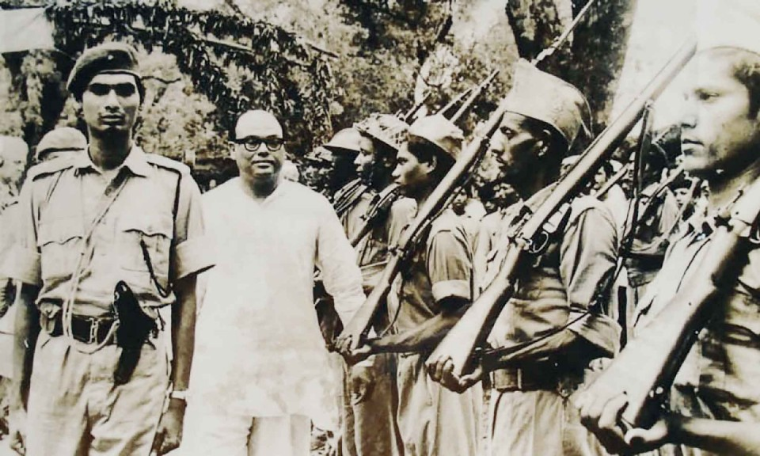
Historical guard of honor to the Acting President of Mujibnagar government, Syed Nazrul Islam on 17th April 1971, led by SP Mahbub Uddin Ahmed, Bir Bikram.
The post-election period was a time of hope, for never had a people spoken so decisively in the history of parliamentary democracy. It was widely believed in both wings that a viable constitution based on six points could be worked out. […]
The first major talks over Pakistan's political future took place between General Yaya and Sheikh Mujibur Rahman in Mid-January. In this session General Yahya probed the extent of the Awami League's commitment to its programme and was assured that they were fully aware of its implications. But contrary to expectation Yahya did not fully spell out his own ideas about the constitution. General Yahya gave the impression of not finding anything seriously objectionable in Six Points but emphasized the need for coming to an understanding with the PPP in Western Pakistan.
The next round of talks took place between the PPP and the Awami League from 27th January, 1971 in Dhaka where Mr. Bhutto and his team held a number of sessions with the Awami League to discuss the constitution.
As in the case with, Mr. Bhutto did not bring any concrete proposals of his own about the nature of the constitution. He and his adviser were mainly interested in discussing the implications of Six Points. […]
It must be made clear that when the PPP left Dhaka there was no indication from their part that a deadlock had been reached with the Awami League. Rather they confirmed that all doors were open and that following a round of talks with the West Pakistani leaders the PPP would either have a second and more substantive round of talks with the Awami League or would meet in the National Assembly whose committees provided ample opportunity for detailed discussion on the constitution.
Mr. Bhutto's announcement to boycott the National Assembly, therefore, came as a complete surprise. The boycott decision was surprising because Mr. Bhutto had already been accommodated once by the President when he refused Sheikh Mujib's plea for an early session of the Assembly on the 15th of February and fixed it, in line with Mr. Bhutto's preference, for 3rd March. […]
Within the QML itself, half their members had booked their seats and there were signs of revolt within the PPP where many members were wanting to come to Dhaka. Faced with the breakdown of this joint front against Bangladesh, General Yahya obliged Mr. Bhutto on 1st March by postponing the Assembly, not for any definite period, but sine die.[…]
The reaction to the postponement in Bangladesh was inevitable and spontaneous and throughout the land people took to the streets to record their protest at this arbitrary act. […] The popular mood felt that the rights of Bangladesh could never be realized within the framework of Pakistan, where Yahya could so blatantly frustrate the summoning of an assembly proclaimed by his own writ and urged that Sheikh Mujibur Rahman must go for full independence.
Sheikh Mujib however continued to seek a political settlement. In calling for a programme of non-cooperation on 3rd March he chose the weapon of peaceful confrontation against the army of occupation as an attempt to bring them to their senses. This was in itself a major gesture in the face of the cold blooded firing on unarmed demonstrators on the 2nd and 3rd March which had already led to over a thousand casualties.
The course of the non-cooperation movement is now a part of history. […]
In this situation the Awami League without being a formally constituted Government, was forced to take on the responsibility of keeping the economy and administration running whilst non-cooperation lasted. In this task they had the unqualified support not only of the people but the administration and the business community. […]
In these unique circumstances the economy and administration were kept going in spite of the formidable problems arising out of the power vacuum which has suddenly emerged in Bangladesh.[…]
Faced with this demonstration of total support to the Awami League and this historic non-cooperation movement, General Yahya appears to have modified his tactics. On the 6th March, he still seemed determined to provoke a confrontation when he made his highly provocative speech putting the full blame for the crisis, on the Awami League and not even referring to the architect of the crisis, Mr. Bhutto. It seems that he expected a declaration of independence on 7th March. The Army in Dhaka was put on full alert to crush the move and Lt. Gen. Tikka Khan was flown in to replace Lt. Gen. Yakub to signify the hardening of attitudes within the Junta.
Sheikh Mujib, however, once again opted for the path of political settlement in spite of massive public sentiment for independence. In presenting his 4-point proposal for attending the National Assembly he not only had to contain the public mood but to leave a way open for to explore this last chance of a peaceful settlement.
It is now clear that Yahya and his Generals never had the slightest intention of solving Pakistan's political crisis peacefully but were only interested in buying time to permit the reinforcement of their military machine within Bangladesh. Yahya's visit to Dhaka was a mere cover for his plan of genocide. It now becomes clear that contingency plans for such a crisis had already begun well in advance of the crisis. […]
As part of this strategy of deception Yahya adopted the most conciliatory posture in his talks with Mujib. In the talks beginning on the 16th of March, he expressed regrets for what had happened and his sincere desire for a political settlement. In a crucial meeting with Sheikh Mujib he was asked to positively state the Juntas position on the Awami Leagues 4-point proposal. He indicated that there was no serious objection and that an interim constitution could be worked out by the respective adviser embodying the four points. […]
Contrary to the distortions now put out by both Yahya and Bhutto the proposal for separate sittings of the Assembly was suggested by Yahya to accommodate Mr. Bhutto. He cited the practical advantage that whilst 6-points provided a viable blueprint to regulate relations between Bangladesh and the Center its application would raise serious difficulties in the West Wing. For this reason West Wing MNAs must be permitted to get together to work out a new pattern of relationships in the context of the Six-point constitution and the dissolution of One Unit.
Once this agreement in principle had been reached between Sheikh Mujib and Yahya there was only the question of defining the powers of Bangladesh vis-a-vis the Center during the interim phase. Here it was again jointly agreed that the distribution of power should as far as possible approximate to the final constitution approved by the National Assembly which, it was expected, would be based on Six Points.
For working out this part of the interim settlement Mr. M. M. Ahmed, the Economic Advisor to the President was specially flown in. In his talks with the Awami League adviser he made it clear that provided the political agreement had been reached there were no insuperable problem to working out some version of Six Points even in the interim period. […]
It must be made clear that at no stage was there any breakdown of talks or any indication by General Yahya or his team that they had a final position which could not be abandoned.
The question of legal cover for the transfer of power is merely another belated fabrication by Yahya to cover his genocide. He and his team had agreed that, in line with the precedence of the Indian Independence Act of 1947, power could be transferred by Presidential Proclamation. The notion that there would be no legal cover to the agreement raised subsequently by Mr. Bhutto and endorsed by General Yahya was never a bone of contention between Sheikh Mujib and Yahya. […]
Whilst hope for a settlement was being raised more ominous signs of the intentions of the army were provided by their sudden decision to unload the munition ship M.V. Swat berthed at Chittagong Port. Preparatory to this decision, Brigadier Mazumdar, a Bengali officer commanding the garrison in Chittagong had been suddenly removed from his command and replaced by a West Pakistani. […] The issue was raised by the Awami League with General Peerzada as to why this escalation was being permitted whilst talks were still going on. He gave no answer beyond a promise to pass it on to General Yahya.
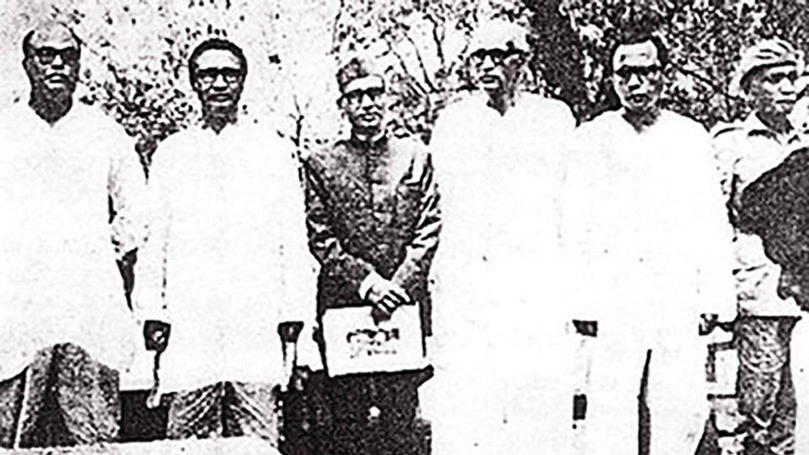
Members of the Bangladesh government-in-exile.
Following the final meeting between General Yahya's and Awami League's advisers on 24th March where Mr. M.M. Ahmed passed on his amendments, a call was awaited from General Peerzada for a final session where the draft could be finalized. No such call materialized and instead it was learnt that Mr. M. M. Ahmed, who was central to the negotiations, had suddenly left for Karachi on the 25th morning without any warning to the Awami League team.
By 11P.M. of the 25th all preparations were ready and the troops began to take up their positions in the city. In an act of treachery unparalleled in contemporary history a programme of calculated genocide was unleashed on the peaceful and unsuspecting population of Dhaka by midnight of 25th March. No ultimatum was given to the Awami League by Yahya, no curfew order as even issued when the machine guns, artillery and canon on the tanks unleashed their reign of death and destruction. By the time the first Martial Law proclamations issued by Lt. General Tikka Khann were broadcast the next morning some 50,000 people, most of them without offering any resistance, and many women and children, had been butchered. Dhaka had been turned into an inferno with fires raging in most corners of the city. Sleeping inhabitants who have been drawn from their homes by the fires started by the military, were machine gunned as they ran to escape the flames. […]
Pakistan is now dead and buried under a mountain of corpses. The hundreds and thousands of people murdered by the army in Bangladesh will act as an impenetrable barrier between West Pakistan and the people of Bangladesh. […]
This is a point of major significance to those great powers who choose to ignore this largest single act of genocide since the days of Belsen and Auschwitz. If they think they are preserving the unity of Pakistan they can forget it because Yahya himself has no illusions about the future of Pakistan.
They must realize that Pakistan is dead and murdered by Yahya - and that independent Bangladesh is a reality sustained by the indestructible will and courage of 75 million Bangles who are daily nurturing the roots of this new nationhood with their blood. No power on earth can unmake this new nation and sooner or later both big and small powers will have to accept it into the world fraternity.
It is therefore, in the interest of politics as much as humanity for the big powers to put their full pressure on Yahya to cage his killers and bring them back to West Pakistan. […]
In our struggle for survival we seek the friendship of all people, the big powers and the small. We do not aspire to join any bloc or pact but will seek assistance from those who give it in a spirit of goodwill free from any desire to control our destinies. We have struggled far too long for our self determination to permit ourselves to become anyone's satellite.
We now appeal to the nations of the world for recognition and assistance both material and moral in our struggle for nationhood. Every day this is delayed a thousand lives are lost and more of Bangladeshi vital assets are destroyed. In the name of Humanity act now and earn our undying friendship.
This we now present to the world as the case of the people of Bangladesh. Bangladesh has earned her right to recognition at great cost, as the people of Bangladesh made sacrifices of unequal magnitude and fought hard in order to establish the rightful place for Bangladesh in the community of Nations.
This is an abridged version. The full statement is available in the online version.
Collected from the daily star….

