‘Safe Back to School’ campaign covers 10,000 schools

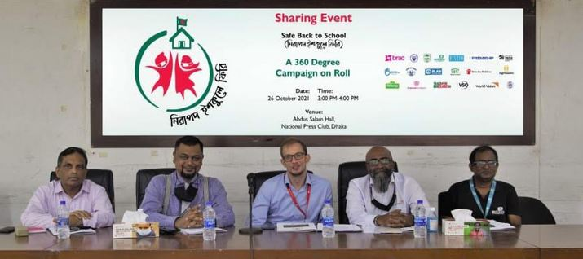
‘Safe Back to School’ campaign covers 10,000 schools

The ‘Safe Back to School’ alliance is running a campaign with the government to raise awareness on behavioural change among children, ensuring that they comply with Covid-19 health advisories in schools.

Alongside the government, the campaign is leveraging all the available mediums of communication to create countrywide awareness to ensure safe return and safe learning environment for children in schools. The implementing partners briefed the current activities and future plan of the campaign at a press conference at the National Press Club in Dhaka on Tuesday.

The organisations running the campaign are - BRAC, Campaign for Popular Education, Dhaka Ahsania Mission, Educo Bangladesh, FIVDB, Friendship, Habitat for Humanity Bangladesh, Handicap International – Humanity & Inclusion, Jagoroni Chakra Foundation, Plan International Bangladesh, Room to Read Bangladesh, Save the Children in Bangladesh, Sightsavers Bangladesh, Sesame Workshop Bangladesh, Stromme Foundation, Teach for Bangladesh, VSO, World Vision Bangladesh and YPSA.

Besides the countrywide awareness campaign using messaging through different channels, the alliance members are also implementing diverse activities in more than 10 thousand schools across 56 districts to promote behavioural change in children to help them grow habits to follow the Covid-19 precautions.

The government and its stakeholders took children safety as their top priority before the educational institutions were re-opened on September 12 to make sure that children return to and continue school with all kinds of protection against Covid-19. To drive the effort 19 national and international development organisations launched ‘Safe Back to School’ campaign on 10 February this year.

BRAC’s senior director KAM Morshed in the press conference said that the campaign has been particularly designed to disseminate messages to all children and their families through all possible communication channels.

“We are using all the available mediums of communication – mass media, social media and word of mouth. These messages are promoting behaviour change in children to help them adopt the Covid-19 precautions of hand washing, mask wearing, social distancing as habits,” said KAM Morshed.

Communications manager at World Vision Bangladesh Devashish Ranjan Sarker moderated the event, while Save the Children in Bangladesh senior manager (media and communications) Nusrat Amin briefed on the different contents developed under the campaign. The contents, among others, include an audio-visual advertisement by popular band group Joler Gaan themed on awareness messaging for children to be aired soon on television channels and social media.

Save the Children in Bangladesh country director Onno Van Manen requested mass media to highlight different contents on the need for importance of education to encourage children to return to school to recover last one year and a half’s Covid-19 induced learning loss.

Tony Michael Gomes, director (Communications, Advocacy) at World Vision Bangladesh, said all the alliance members working in the field of education is making sure that the available resource are mobilised to keep the schools safe.

IH/GY

