Australian life expectancy rises despite COVID-19: study
ount : 220
Observer Online Desk

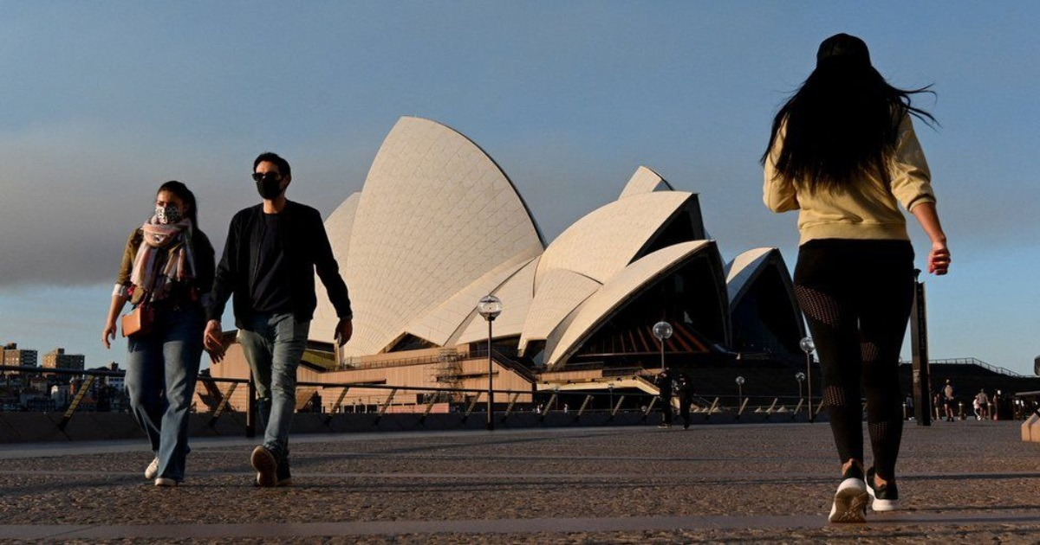
Australian life expectancy rises despite COVID-19: study

Life expectancy for Australians has increased to a record high during the COVID-19 pandemic.
In a study published on Monday, researchers from Australian National University (ANU) found that life expectancy for both Australian males and females increased by 0.7 years between 2019 and the first year of the coronavirus pandemic in 2020, reports Xinhua.
The increase far outstripped the average growth of between 0.09 and 0.14 years recorded in Australia between 2015 and 2019, according to the Canberra Times.
By comparison, life expectancy in the United States fell by 1.7 years for women and 2.2 years for men in 2020.
Vladimir Canudas-Romo, co-author of the study from ANU's School of Demography, said the significant difference could be attributed to Australia's quick response to the pandemic.
"Australia was in a unique position to be able to close borders to the rest of the world. Now with the strong compliance on vaccinations, we are likely to be one of the safest places in the world," he was quoted by the Canberra Times.
The ANU researchers found that COVID-19 containment measures introduced in 2020 caused a "sharp decline in the spread of other infectious diseases," with deaths from pneumonia and influenza falling 20 percent.
A sharp decline in social mobility due to lockdowns and travel restrictions also caused a significant decline in the number of road deaths.
"Coronavirus was among the few causes of death that really increased from 2019 to 2020 ... in the case of the United States there was an extreme case of COVID strongly declining life expectancy," Canudas-Romo said.
"In Australia even when mortality increased due to COVID, we still had so much decline in infectious diseases, accidents, heart attacks and strokes, that our life expectancy increased by three-quarters of a year," he said.

TF

